We are delighted to welcome two new members of staff to the surgery team.

Lynne Greene is a new member of the reception team.

Dr Robin Simpson who has already been working at the Surgery for some time, will now be formally joining the GP team every Friday.

**Ordering Prescriptions**

**Please note: We will no longer be processing prescription requests over the telephone.** Exceptions do apply for our frail and elderly patients and those who find it very difficult to visit the surgery or use the patient online access service. If you think you are eligible for this service please ask at reception.

December seen our Foundation Doctors, Dr’s Hart and Brannon move onto their next rotation and we now welcome Dr Lucy Hanson and Dr Isra Hale who will be here until March 2020, we hope you will join with us in giving them a warm welcome.

You can now book an appointment to see a GP or nurse either during the evening or at the weekend. Some of the appointments will be available at the practice, whilst others at the hub at Blossomfield Surgery, Blossomfield Road, Solihull.

Speak to one of the practice team for more information about what appointments are available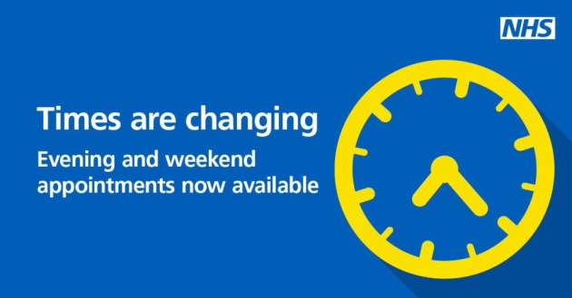

**The Influenza vaccine is still available this winter for all eligible patients.**

If you would like to have the vaccine, please book an appointment with a nurse. You can do this by either using your online access if you have it or calling the surgery on 01675 442510

**Those eligible for seasonal influenza vaccines are:** All those aged 65 & over and all those aged 6 months & over and in one of the clinical groups listed below:

**Patients with**

Chronic respiratory disease including Asthma and COPD

Chronic Heart disease Chronic renal failure Heart failure Immunosuppression

Diabetes Chronic liver disease

Pregnant Woman Some neurological conditions

Carers Obesity

**Pneumococcal Vaccination:**

In addition to the flu vaccine we also offer the opportunity to be vaccinated against one of the types of pneumonia which may affect people as they get older. The Chief Medical Officer recommends anyone over 65 years of age should have this vaccine. Unlike the yearly seasonal flu vaccine, the pneumococcal vaccine usually only needs to be administered once. It can be given at the same time as the flu vaccine so if you think you are eligible please advise at the time of booking please mention this when booking you appointment.

**Flu** is an unpleasant illness which can have serious complications for at risk groups. It is very infectious and easily spread to others. For more information on the symptoms and how to reduce the spread of flu follow the link to the NHS website: <https://www.nhs.uk/conditions/flu/>

Contact your local pharmacist for treatment advice.