**Repeat Prescriptions**

During the Covid 19 pandemic we are currently accepting repeat prescriptions over the phone.

They can also be ordered online via the Patient Access service, for more information on this, access the practice website [www.hamptonsurgery.co.uk](http://www.hamptonsurgery.co.uk) or ask at reception for a form to register for this service.

Please allow 48 hour before collecting from the pharmacy.

**Electronic Prescribing Service (EPS)** - The practice offers the EPS service which allows your prescriptions to be sent electronically to the pharmacy of your choice. Please ask at the pharmacy of your choosing to complete the forms to nominate them.

Any unwanted/unused medication should be returned to your local pharmacy and not to the surgery as we are unable to dispose of these.

**Test Results** – The surgery receives many hospital letters and test results daily and we ask that patients contact us for any results they require. Please telephone for test results in the afternoon after 2.30pm whenever possible.

A Full range of medical services are available at the surgery including:

* Adult & Childhood Vaccinations
* Sexual health & Family planning
* Anticoagulation monitoring
* Weight management
* Smoking Cessation
* Chronic Disease monitoring
* Antenatal Clinic
* Minor Surgery (to restart again soon, date TBC)

***The Doctors***

Dr Ryan Prince, MB, ChB, MRCGP

(Qualified Birmingham, 1995) GP Partner

Dr Rodger Charlton, MB, ChB, MD, FRCGP

(Qualified Birmingham, 1983) Salaried GP

Dr Robin Simpson GP retainer

Dr Yasin Al-Shammary - General Practitioner - MBChB MRCGP – Salaried GP

***Nurse Partner, Practice Manager & Clinical Lead***

Kirsty Millard RGN

***Deputy Practice Manager***

Mr Bill McAreavey

***Practice Nurses***

Sister Kirsty Millard RGN, Independent Prescriber

Louise Haines RGN

***Reception & Administration Team***

Mrs Jane Hunt, Mrs D McNeary, Mrs Lynne Green, Ms Bev Watson & Mrs Leah Prince

***Healthcare Assistant***

Ms Bev Watson

## The Practice has the following staff attached to the surgery

## Midwife, Psychologist

Health Visitor,

and CCG Prescribing Pharmacist

***Teaching/ Training***

The practice is a training practice and has on occasions both medical students and qualified doctors undertaking further training based at the surgery. Please inform the receptionist if you prefer not to have a student observing your consultation with your GP.

**Surgery Opening Times**

|  |  |
| --- | --- |
| Day | Time |
| Monday, Tuesday, Wednesday & Friday | 8:30 to 13:00  14:30 to 18:00 |
| Thursday | 8:30 to 13:00 |

**Appointments:** Appointments can be made by phone or in person. All patients are allocated a telephone appointment in the 1st instance and if necessary seen by the GP by appointment. Where possible we try to provide patients with an appointment with the practitioner of their choice. If your appointment is urgent we will provide same day access with any practitioner.

**Home Visits:** Home visits are for people who are house bound; there is no obligation for a doctor to visit if it is not necessary to do so. Visits are made at the doctor’s discretion. If you require a home visit, please let the receptionist know before 10:00am wherever possible.

**Out of Hours Service (OOH)**

**Call 01675 442510**

If you need to speak to a Doctor urgently out of the practice opening times then please call 01675 442510 and listen to the information before deciding what to do next.

Out of hours cover is commissioned by our contracting authority and is provided by NHS 111 (call 111) or BADGER (which has a base at Solihull hospital).

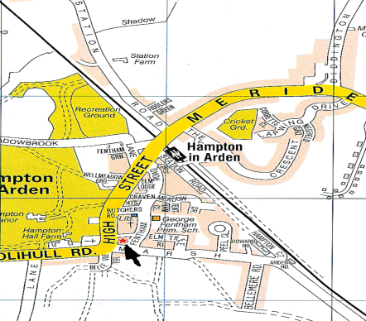

**HAMPTON SURGERY**

**Practice Information**

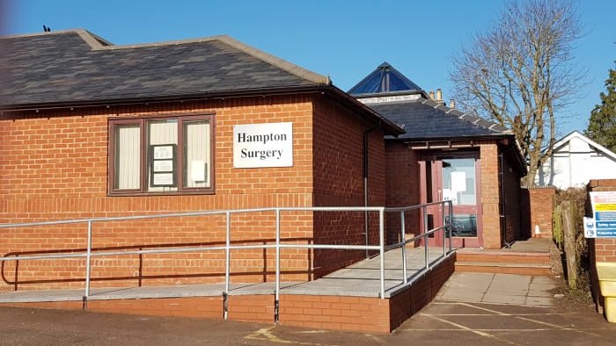

Tel: 01675 442510

Fentham Hall

Marsh Lane

Hampton in Arden

B92 0AH

[www.hamptonsurgery.co.uk](http://www.hamptonsurgery.co.uk)

The Practice area extends up to approximately 2.5 miles from the village of Hampton in Arden

## Registration - If you are interested in registering with the practice and would like any further information, the staff will be happy to help.

It will be necessary to complete a family doctor services registration form which can be obtained from reception and arrange a new patient medical assessment. Please note that patients are registered with the practice and not a particular Doctor.

Named GP - From the 1st April 2015 practices are required under their contract to allocate a named GP to ALL patients including children. All patients at the surgery have been allocated a named GP who is responsible for generally over seeing your medical care. However for your day to day consultations or if your named GP is not available you can continue to see any Doctor within the practice. Your named GP can be found on the left hand side of your prescription.

## As a patient you do not have to take any further action, but if you have any queries regarding this please do not hesitate to contact the practice manager to discuss.

Communication with Patients – the Practice has a Patient Participation Group (PPG) which along with the Practice Manager welcomes any comments or suggestions about the services we provide. You can contact the Chairman of the PPG by leaving a message for him at reception

In conjunction with the PPG the practice produces a quarterly newsletter which can be found on our website ww.hamptonsurgery.co.uk which also provides more detail about the services the practice provides.

**This leaflet is available in different formats if required.**

**Please ask at reception.**

**Accessibility Standards - We want to get better at communicating with our patients.  We want to make sure that all patients can understand the different types of information that is given to them.**

**If you have any problems with communication please let the practice know when you return these forms.  We aim to meet all patient communication needs.**

**Patient information.** Whatever is disclosed in the doctor-patient consultation is confidential between the patient and doctor. From time to time NHS organisations (who are subject to a duty of confidentiality), need to monitor diseases and their treatment, as well as assessing the quality of the service being provided in the practice.

Hampton Surgery also from time participates in primary care research. Any data disclosed will be kept to a minimum required to serve the purpose and where possible be anonymised before disclosure. If you are concerned about any of the ways in which your confidential data is being used further information is available from the practice manager.

Under section seven of the Data Protection Act, patients have the right to apply to access their medical records. Further information is available from the practice manager

**Patients’ rights and responsibilities.** You have a right to expect a high standard of medical care from our practice and we will try at all times to provide the best care possible with the resources available. In order to assist us in this we need you to take full responsibility for keeping appointments and to order prescriptions in a timely manner.

We aim to provide a high standard of service, but if you feel you have a reason to complain, please ask for a copy of our practice complaints procedure which is available from the surgery. Please ask to speak to the Practice Manager any time you feel you have a cause for complaint. The Practice Manager is also happy to discuss any comments or suggestions you may have about Hampton Surgery.

Very occasionally a practice/patient relationship becomes untenable. In this situation the patient may wish to register elsewhere. The NHS operates a Zero Tolerance Policy with regard to violence and abuse and the practice has the right to remove abusive patients from its list with immediate effect. This would generally happen following a warning and a failure to rectify the situation. In these circumstances patients will be notified in writing and the reason for removal will be recorded. The national Commissioning Board is responsible for arranging further medical care for such patients.

**The partners listed in the practice form a non-limited partnership to provide general medical services**